Certain important commands in command line Command Line Windows and Git/Github

Creating a new folder



Changing directory



Creating an empty file inside the folder



Checking all the folders and files inside

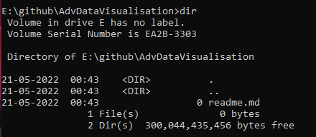

Open file using notepad



git init



git status

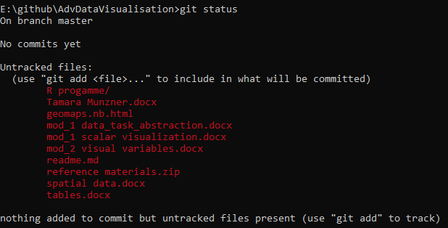git add . 🡪 The git add command **adds a change in the working directory to the staging area**. It tells Git that you want to include updates to a particular file in the next commit. However, git add doesn't really affect the repository in any significant way—changes are not actually recorded until you run git commit

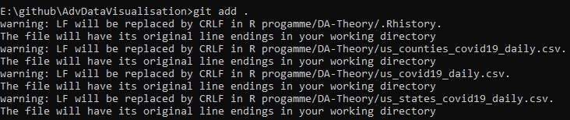

git status

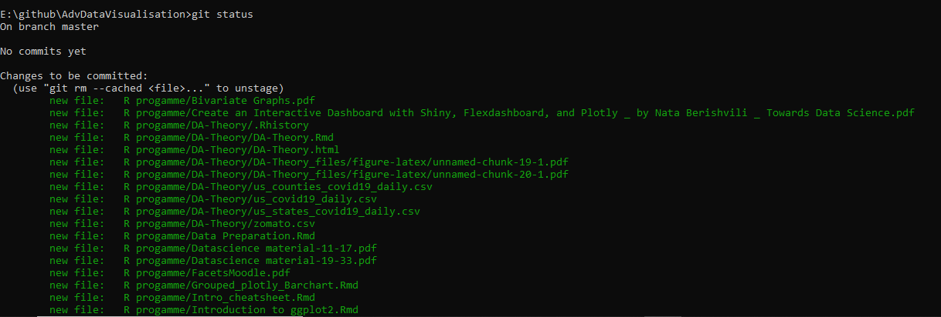 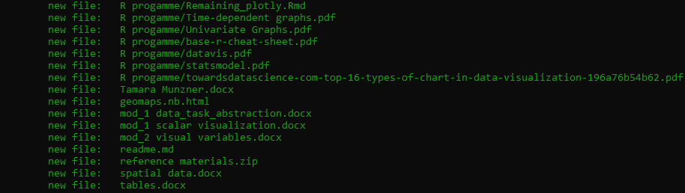

git commit -m “” 🡪 git commit command is one of the core primary functions of Git. Prior use of the git add command is required to select the changes that will be staged for the next commit. Then git commit is used **to create a snapshot of the staged changes along a timeline of a Git projects history**.

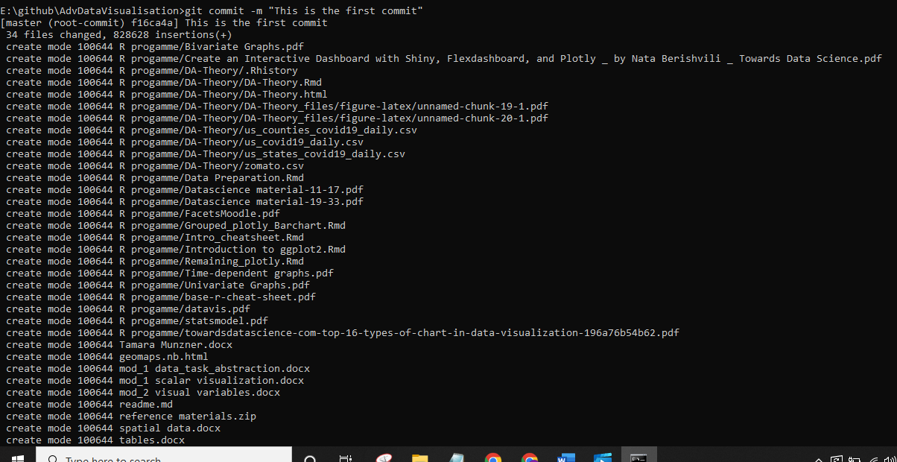

Linking our document to one created by github



Pushing changes to the repo

git push 🡪 git push command is used **to upload local repository content to a remote repository**

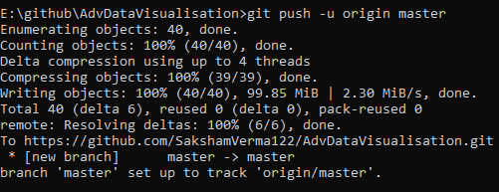

If you change something in any of the files

